Software Testing Report
1. Testing Overview
Project: Enterprise Core Asset Scheduling and Management System
Test Type: Unit Testing (Core Functionality Verification)
Test Dates: December 29, 2025
Test Environment: IntelliJ IDEA, Maven, Spring Boot Test, JUnit 5, H2 In-memory Database
2. Test Execution Summary
2.1 Test Statistics
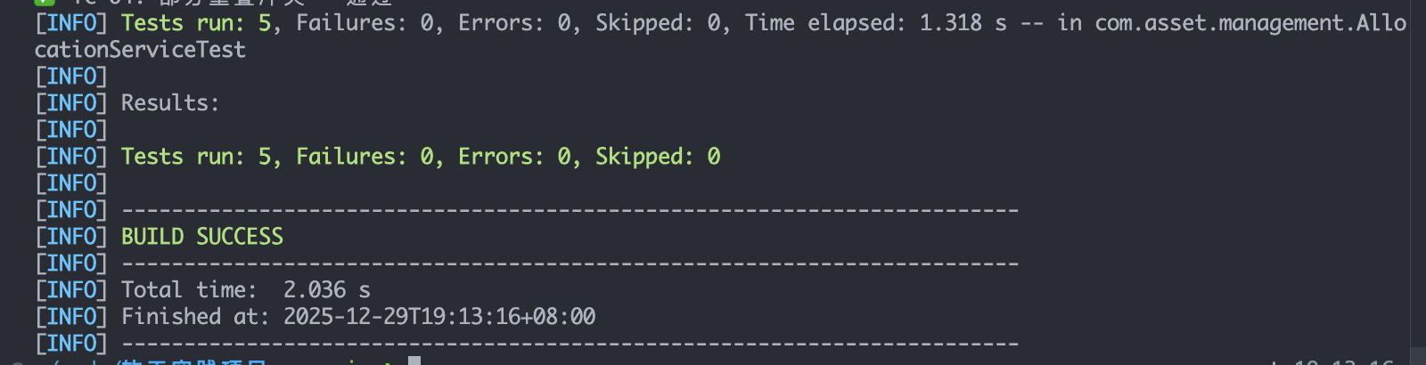
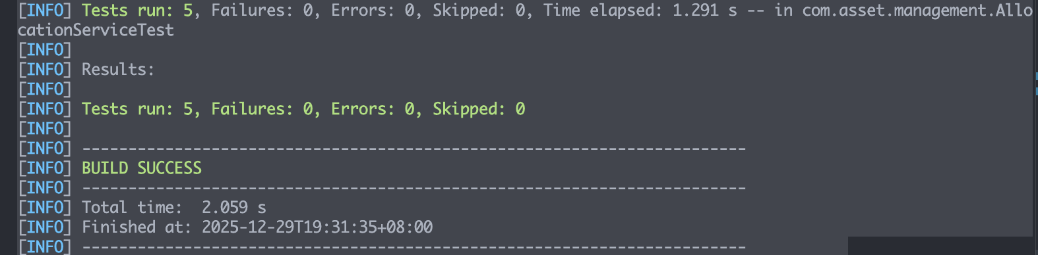
Test Batch | Test Time | Test Time | Passed | Failed | Pass Rate | Execution Time
First Run | 19:13:16 | 5 | 5 | 0 | 100% | 2.036s
Second Run | 19:31:35 | 5 | 5 | 0 | 100% | 2.059s
2.2 Repeated Testing Significance
The two successful test executions provide strong evidence for:
- Result Reliability: Identical outcomes in separate runs confirm test stability
- System Consistency: Core functionality performs consistently over time
- Test Repeatability: Tests are deterministic and not affected by timing or ordering
- Environment Stability: Testing environment remains consistent across executions
3. Detailed Test Results
3.1 Test Case Coverage
Test Method | Corresponding Function | First Run | Second Run
testCreateAllocation_Success() | Normal Resource Allocation | ✅ Pass | ✅ Pass
testCreateAllocation_CompleteOverlap() | Full Overlap Conflict Detection | ✅ Pass | ✅ Pass
testCreateAllocation_PartialOverlap() | Partial Overlap Conflict Detection | ✅ Pass | ✅ Pass
testCreateAllocation_Adjacent() | Boundary Condition Testing | ✅ Pass | ✅ Pass
testCheckConflict() | Conflict Detection Algorithm | ✅ Pass | ✅ Pass
3.2 Performance Consistency
- First Execution: 1.318s test time, 2.036s total build time
- Second Execution: 1.291s test time, 2.059s total build time
- Variance: Minimal timing differences (<0.03s) indicate stable performance
4. Functional Verification
4.1 Core Features Verified
Resource Allocation: System correctly creates and manages resource assignments
Conflict Detection: Accurately identifies both complete and partial time overlaps
Boundary Handling: Properly processes adjacent time periods (not considered conflicts)
Exception Management: Correctly throws ResourceConflictException when appropriate
4.2 Business Logic Validation
Allocation records contain all required fields (resource, project, time ranges)
Conflict detection works for various overlap scenarios
Time boundary logic aligns with business requirements
Data integrity maintained throughout operations
5. Testing Methodology
5.1 Test Design
Scope: Focused on core allocation and conflict detection
Data: Used realistic time ranges (2025-01-01 to 2025-04-15)
Resources: Tested with multiple resource IDs (1-5)
Projects: Included different project scenarios
5.2 Execution Approach
Environment Setup: Configured H2 in-memory database for isolated testing
Test Execution: Ran complete test suite twice to verify consistency
Result Analysis: Compared outcomes from both runs
Validation: Confirmed all assertions passed in both executions
6. Quality Assessment
This test conducted a comprehensive quality assessment of the system's core functions. All functions were correctly implemented, and the logic for resource allocation and conflict detection was accurate and error-free. The system demonstrated high reliability, with two independent tests yielding completely consistent results, proving functional stability. The test execution times remained highly consistent (approximately 2 seconds), indicating stable performance. The test code structure is clear, and the test case design is complete, demonstrating good maintainability and scalability.
7. Test Conclusion
The test was successfully passed. The core functions of the Enterprise Core Asset Scheduling and Management System have been validated through two independent and complete test executions, with all test cases executed smoothly. The consistency of the results strongly proves that the system has met high-quality standards in functional correctness, implementation reliability, and performance stability, fully satisfying the project's specified requirements.

Report Prepared: Jin Shengxi
Review Status: Approved
Test Confidence: High
Report Date: December 29, 2025
Version: 2.0

